MyWebMethods Transactions

Production URL: <http://prodeai13:8585/>

Test URL: <http://testeai13:8585/>

Dev URL: <http://deveai7:8585/>

Just for clarity, I’ll use “Dell Onhand To SCP” as an example throughout the guide.

Once you have access to MyWebMethods go ahead and log in. There will be a gray navigation sidebar on left side of the home page. On that navigation side bar go to Applications > Monitoring > Integration > B2B > Transactions.

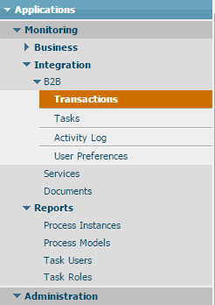

Now we are at the transactions page where we will search for specific transactions based on tons of different filters. The first thing you want to do is make sure you are on the correct server. In the upper right hand corner there is a field labeled “TN Server”. Make sure this is set to either B2B node 1 or B2B node 2. Most transactions to TN will go through a B2B node. The A2A nodes are used for only internal transactions. So anything going through an A2A node won’t hit an external partner. 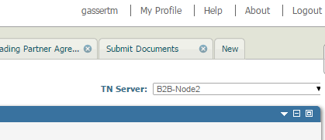

Now we can use the Query Fields catregoryThere are too many to list but I mainly search by receiver, sender, document type, or bizdoc number(SO number). The next step is to pick an operator such as “equals”, “not equals”, “contains”, etc. Finally we decide a value we want to filter on. Sometimes you can enter any value you want other times you have to choose from a drop down of values depending of the field you filter by. The Document type field makes you choose from a list of documents that are populated by the document types in MyWebMethods at the time. A field like bizdoc number you would have to manually enter the value yourself. In this case I chose my field as “Document Type”, operator as “Equals”, and value as “DSH Onhand To SCP”. 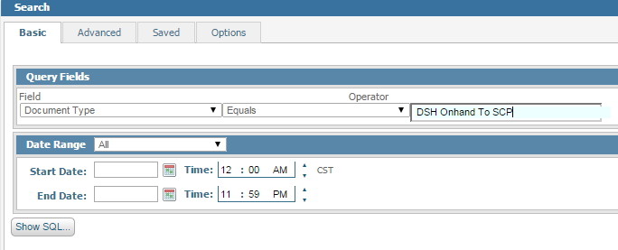

So obviously this will return any transaction that has been sent to TN that has a document type equal to DSH Onhand To SCP. You can also filter by specific days using the start and end date fields. So if you know the exact date of the transaction you can just fill in those fields.

